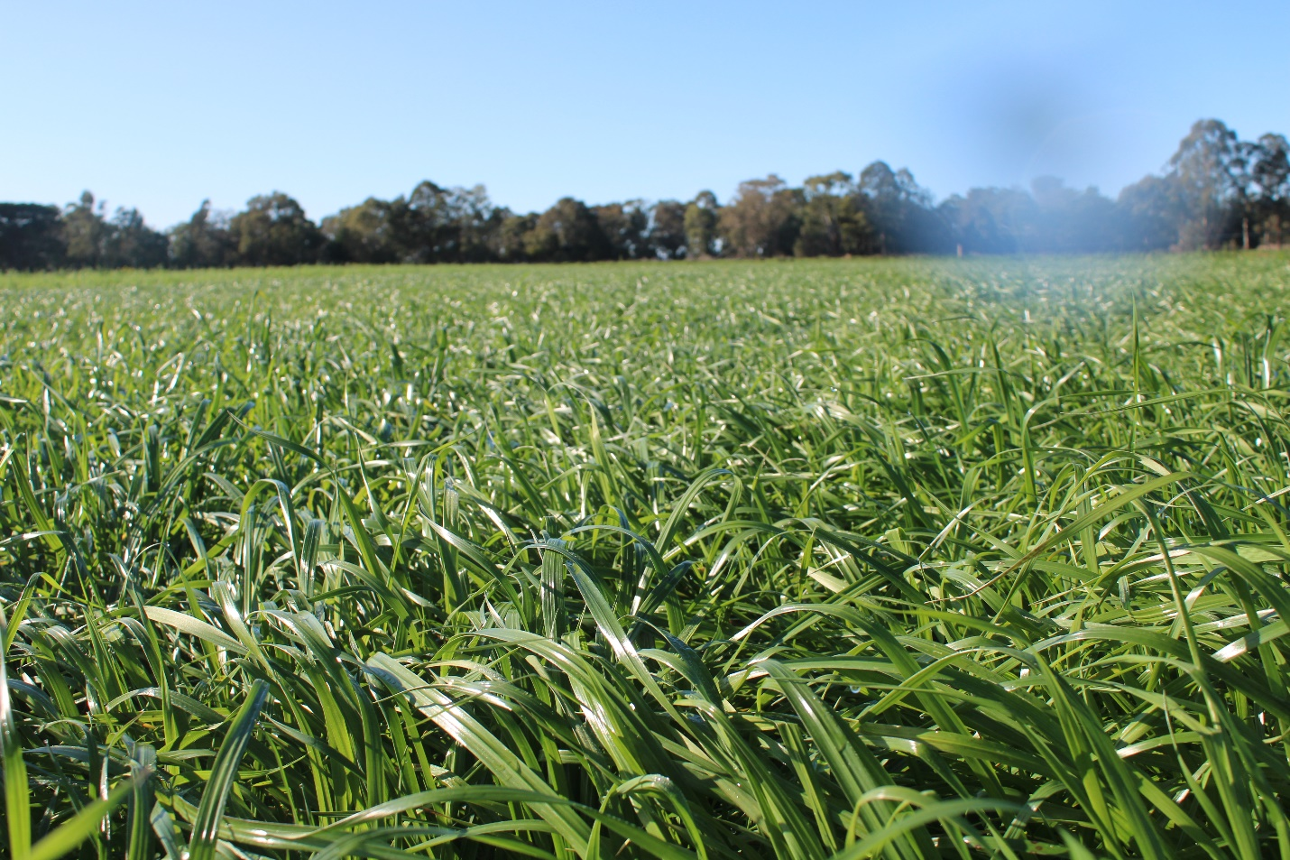
Macalister Demonstration Farm
Latest Farm Data 12/12/2023
Cows On Farm | Milk Solids/Cow | Pasture Cover
280 | 1.47kg/MS | 2400kgDM/Ha
Pasture Growth Rate | Rotation | Rainfall
65-70kgDM/Ha | 22Days | 166mm
Key Numbers | 12/9/2023 | 10/10/23 | 14/11/2023 | 12/12/2023
Farm Area | 73 | 73 | 73 | 73
Grazing Ha available to vat | 50 | 50 | 50 | 63
Renovated Pasture (Ha) | 10 | 10 | 10 | 10
Stock Numbers
Cows currently milking to vat | 224 | 280 | 276 | 270
Cows currently not milking to vat | 10 | 0 | 5 | 10
Total cows on farm | 280 | 280 | 281 | 280
Milk Production
BMCC target below 250 | 238 | 209 | 185 | 217
Milk solids per cow (kg/MS/cow) | 1.86 | 1.86 | 1.80 | 1.47
Fat % | 4.25 | 4.09 | 4.16 | 4.11
Protein % | 3.35 | 3.49 | 3.34 | 3.45
Feed Budget
Average pasture cover | 2650 | 2500 | 2300 | 2400
Current pasture fed (kgDM/cow) | 12 | 12 | 12 | 12
Current concentrate fed (kgDM/cow) | 6 | 6 | 6 | 6
Current demand per cow (kgDM/cow) | 18 | 18 | 18 | 18
Stocking rate (cows/Ha) | 3.95 | 5.6 | 5.52 | 4.44
Pasture growth rate (kgDM/Ha) | 65-70 | 60-70 | 65.-75 | 65-75
Pre-grazing cover (kgDM/Ha) | 2900 | 2800 | 2650 | 2650
Residual (kgDM/Ha) | 1550 | 1500 | 1500 | 1500
Round length (Days) | 30 | 23 | 25 | 22
Farm Conditions
Soil temperature (degree C) | 13 | 13 | 15 | 16
Rainfall (MM) | 22 |  | 4 | 166
Irrigation days this last fortnight (days) | 2 | 0 | 3 | 2

Farm insights
The last two months have been difficult given the extreme weather events. This has impacted on pasture and cow production however the farm has got through with minimal damage to the pastures. One round of fertiliser was not applied due to the wet conditions. Urea is now being applied at 80kg/ha and we are seeing the pastures bounce back quickly after grazing. Pasture management has been excellent with no paddocks needing to be topped and seed head is just starting to be noticeable in the early to mid-flowering varieties. The export heifers are being utilised to manage the residuals by following the milkers if required. Docks have been sprayed with a good kill, but the paddocks chosen for summer crop are too wet to be sown down and a decision has been made to leave them until mid-February and sow down to Italian ryegrass. They will also be cleaned up with a follow up spray prior to sowing for optimum weed control. The laneways are in good order and have had minimal damage from the flooding. Spraying of channel banks will continue with a focus on the thistles and blackberries.
Cow health and condition is generally very good with only 10 cows in the red herd at present. The last three herd tests have identified five cows which have high BMCC, these cows have now been moved to the red herd. Given the climatic conditions the pastures will have spore counts and the herd will be monitored for Facial eczema. The supplementary feed will return to wheat with the addition of calci-prill with the possibility of zinc being added if required.

